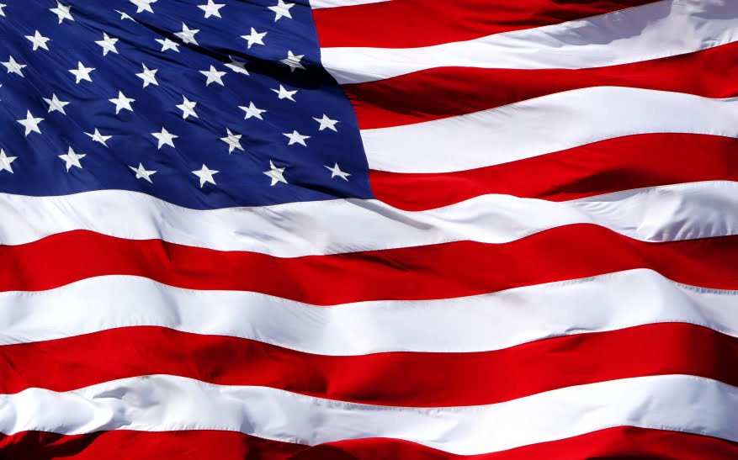

***You are invited to the Bullhead City Municipal Court Veteran’s Treatment Court Graduation Ceremony***

*Monday, October 22nd, 2018*

*At 4:00 PM*

*Bullhead City Council Chambers*

*1255 Marina Boulevard*

*Bullhead City, Arizona 86442*

*This is the first graduation ceremony for Justice Involved Veterans since the Treatment Court’s inception in April of 2017*